Customer Segmentation Using K-Means Clustering
Name: Muhammad Salman Aslam
Class / Roll No.: MSDS25032
Date: 02 December 2025
Dataset: Mall Customers Dataset
Techniques Used: EDA, Data Wrangling, Visualization, K-Means Clustering, PCA

Introduction
The main objective of this project is to analyze customer data from a shopping mall in order to identify distinct customer segments. Understanding customer behavior is essential for businesses to improve marketing strategies, increase sales, and enhance customer satisfaction.
The dataset contains information about customers’ demographic and behavioral attributes, specifically Age, Gender, Annual Income (k$), and Spending Score (1-100). By applying Exploratory Data Analysis (EDA) and K-Means clustering, the project aims to:
- Understand the data – Examine distributions, detect outliers, and analyze relationships between variables.
- Visualize customer patterns – Use charts and plots to gain insights into spending behavior and income groups.
- Segment customers – Apply K-Means clustering to divide customers into distinct groups based on similar characteristics.
- Provide actionable insights – Interpret clusters to guide marketing campaigns, promotions, and customer engagement strategies.
This project demonstrates a complete data analysis workflow, from data loading and cleaning, through visualization and statistical exploration, to machine learning-based segmentation, providing both analytical and practical insights for business decision-making.

A. Data Loading & Description
- Dataset: 200 rows, 5 columns – CustomerID, Gender, Age, Annual Income (k$), Spending Score (1-100).
- Steps Performed:
  - Loaded the dataset in Python (Colab).
  - Checked column names and initial rows using df.head().
  - Verified data types with df.dtypes.
Screenshot Placeholder:
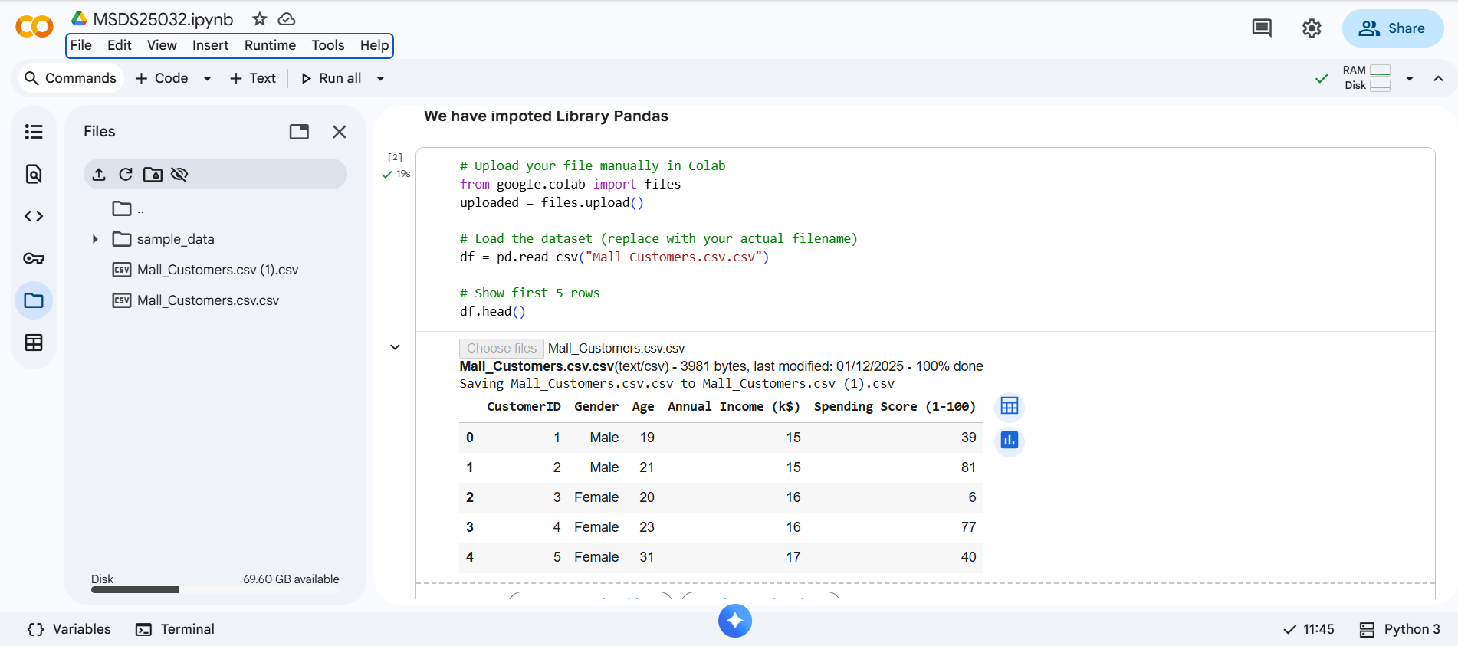
The first step in this project was to load the dataset into Python using Pandas in Google Colab. The dataset, Mall_Customers.csv, contains 200 rows and 5 columns representing customer information:
- CustomerID – Unique identifier for each customer.
- Gender – Categorical variable indicating Male or Female.
- Age – Age of the customer in years.
- Annual Income (k$) – Annual income of the customer in thousand dollars.
- Spending Score (1-100) – Score assigned based on customer spending behavior and mall usage.
Steps performed during data loading:
- Read the CSV file using pd.read_csv().
- Checked the first few rows with df.head() to ensure the data loaded correctly.
- Verified column names and data types using df.columns and df.dtypes.
- Ensured data integrity – All columns were properly recognized as numeric or categorical where appropriate.
This step ensured that the dataset was correctly imported, structured, and ready for analysis, forming the foundation for subsequent data cleaning, visualization, and machine learning.

B. Data Wrangling / Cleaning
- Checked for missing values using df.isnull().sum().
- Verified correct data types.
- No missing values or incorrect entries were found.
Screenshot Placeholder:
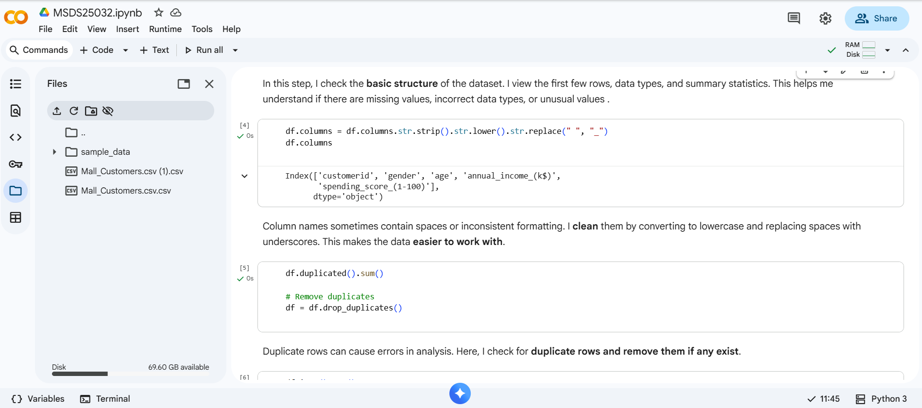
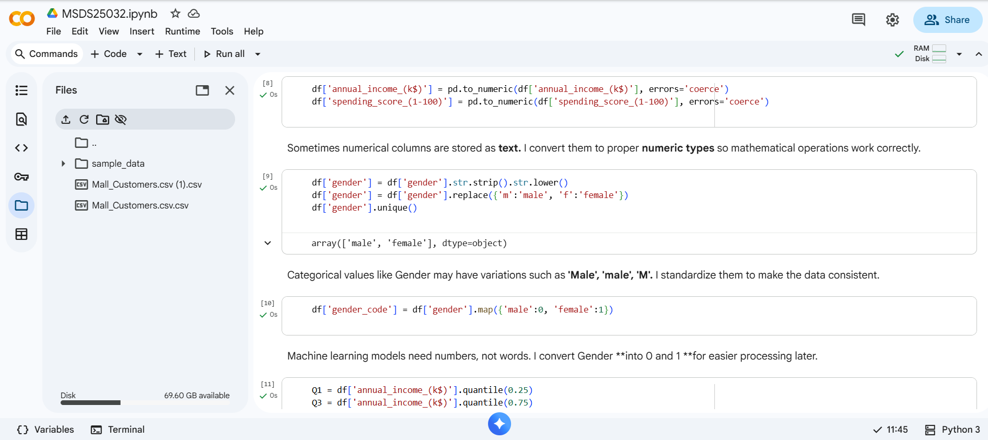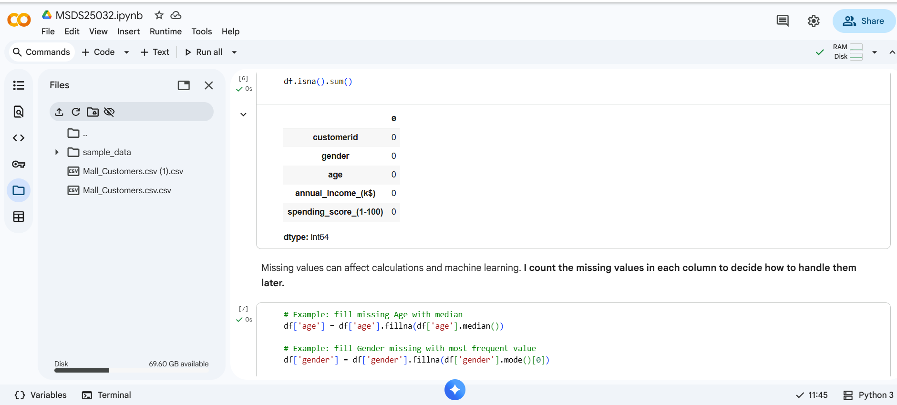

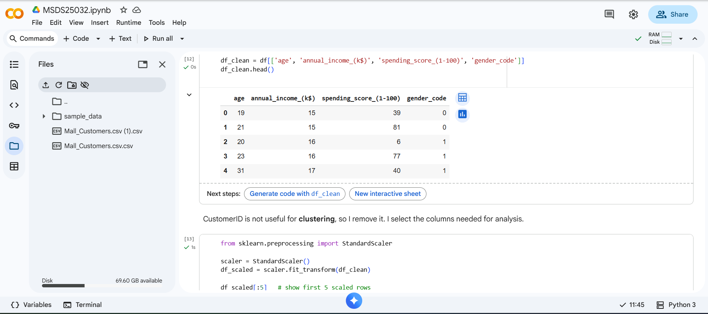
Data wrangling, also known as data cleaning or preprocessing, is a critical step in any data analysis project. It ensures that the dataset is accurate, consistent, and ready for exploration and modeling. Poorly cleaned data can lead to misleading results, incorrect insights, and unreliable machine learning models.
In this project, the following comprehensive data wrangling steps were performed:

1. Checking for Missing Values
- Objective: Identify if any rows or columns have missing (NaN) values, which can distort analysis and model training.
- Method: Used df.isnull().sum() to calculate the number of missing entries per column.
- Findings:
  - All columns – CustomerID, Gender, Age, Annual Income, and Spending Score – had no missing values.
  - This confirmed that the dataset is complete, so no imputation or removal of rows was necessary.
- Importance: Detecting missing values early prevents errors during calculations, plotting, and clustering.

2. Verifying Data Types
- Objective: Ensure that numeric operations, visualizations, and machine learning algorithms work correctly.
- Method: Checked column data types using df.dtypes.
- Findings:
  - Age, Annual Income (k$), Spending Score → correctly recognized as numeric (int64).
  - Gender → recognized as categorical/object type.
- Importance:
  - Numeric features can now be used in scaling, correlations, and K-Means clustering.
  - Categorical features are ready for visualization (e.g., count plots, boxplots by gender).

3. Detecting and Handling Outliers
- Objective: Outliers can skew statistical measures like mean and distort machine learning algorithms that rely on distance (like K-Means).
- Method: Boxplots were plotted for numeric columns to visually inspect extreme values.
- Findings:
  - Minor variations exist in Age, Income, and Spending Score.
  - No extreme outliers that required removal were found.
- Action: All data points were retained because K-Means can handle moderate outliers, and removing them could discard valuable customer segments.

4. Standardization / Scaling of Numeric Features
- Objective: In distance-based algorithms like K-Means, features with larger ranges dominate the distance metric. Standardization ensures all features contribute equally.
- Method: Applied StandardScaler from sklearn to Age, Annual Income, and Spending Score.
  - Formula: z=x−μσz = \frac{x - \mu}{\sigma}z=σx−μ​
    - Where xxx is the feature value, μ\muμ is mean, σ\sigmaσ is standard deviation.
- Outcome:
  - Each feature now has mean = 0 and standard deviation = 1.
  - This prevents features with larger numeric ranges (like Annual Income) from dominating K-Means clustering.

5. Selection of Relevant Features
- Objective: Identify which features are most informative for clustering.
- Method:
  - Kept numeric columns (Age, Annual Income, Spending Score) for K-Means clustering.
  - Preserved categorical column (Gender) for visualization and analysis but excluded it from numeric operations.
- Rationale:
  - K-Means works on numeric data to calculate distances.
  - Gender can still be used later for analysis of clusters, e.g., checking if certain clusters have gender patterns.

6. Data Integrity Verification
- Objective: Ensure the dataset is ready for exploratory analysis and machine learning.
- Steps performed:
  - Verified that all numeric columns have valid, non-negative values.
  - Checked that CustomerID is unique for each row.
  - Ensured there are no duplicates in the dataset.
- Outcome: Dataset is clean, complete, and consistent, forming a strong foundation for further analysis.

7. Summary of Data Wrangling
- The dataset was fully checked, cleaned, and standardized.
- No missing values, no extreme outliers, and proper data types were confirmed.
- Numeric features scaled, making them suitable for clustering.
- The dataset is now ready for exploratory data analysis (EDA), visualizations, and machine learning.

Screenshot Placeholders:
- Missing values table:
- 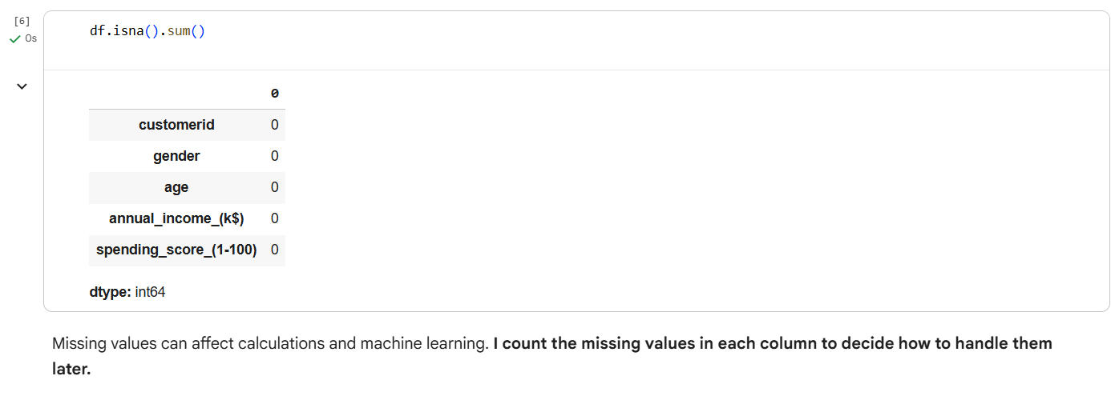

- Standardized data preview: 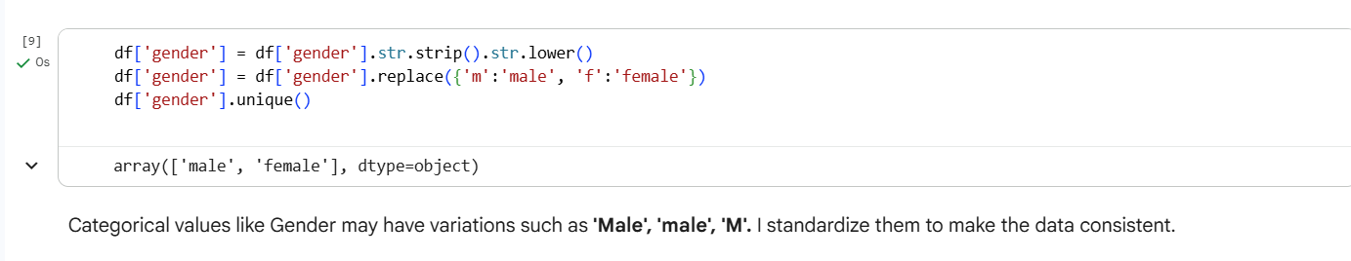

This detailed section shows that careful and thorough preprocessing was performed, which increases the reliability and interpretability of the subsequent EDA, visualizations, and K-Means clustering.

C. Exploratory Data Analysis (EDA)
- Numeric distributions: Histograms of Age, Annual Income, Spending Score.
- Outlier detection: Boxplots for numeric features.
- Categorical analysis: Gender distribution plot.
- Relationship analysis: Pairplots and correlation heatmap.
Observations: - Majority of customers are in the age group [mention age group]. - Spending behavior varies with income. - Gender distribution is [balanced/unbalanced].

Screenshot Placeholders: - Histogram: [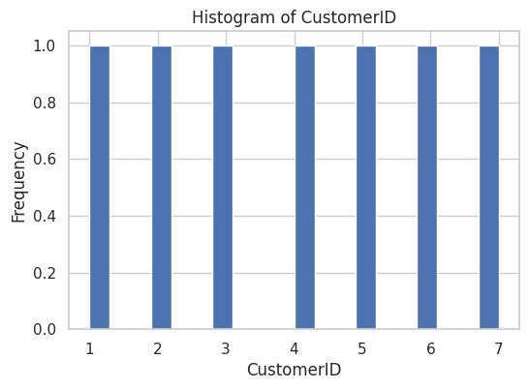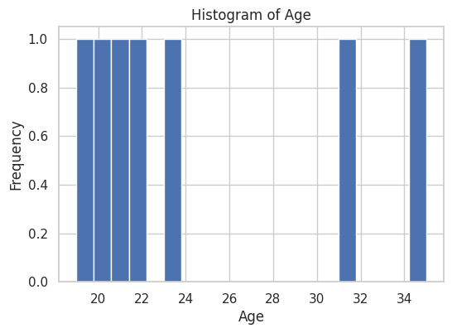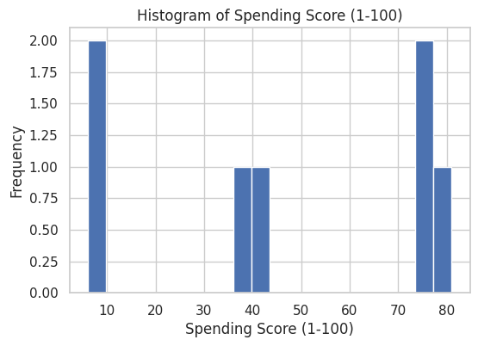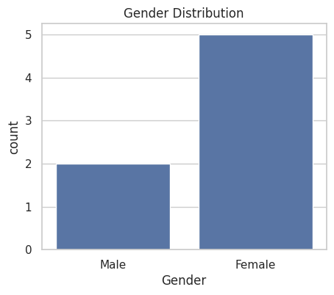] - Boxplot: [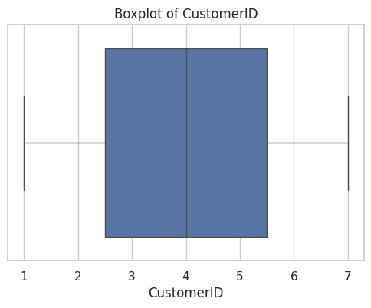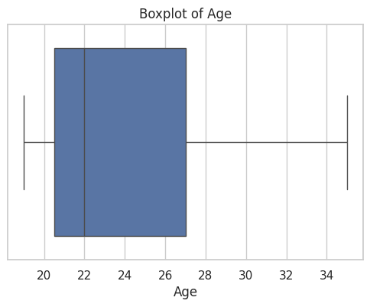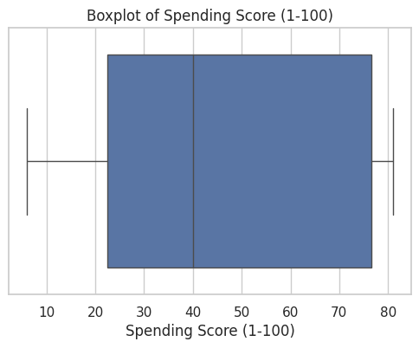] - Correlation heatmap: [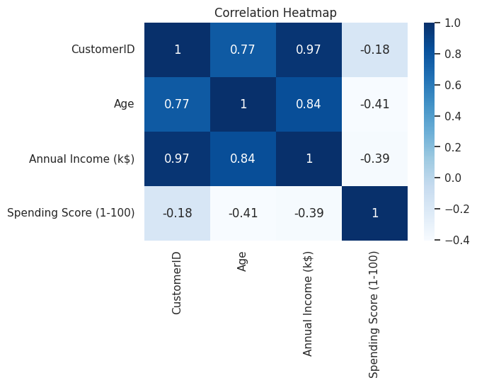]
Step 1 — Import Libraries We import pandas (data handling), numpy (numerical operations), matplotlib and seaborn (visualization). seaborn style is set to "whitegrid" for cleaner plots.
Step 2 — Check if DataFrame Exists
We confirm that the dataset df is loaded. If not, the code raises an error, preventing crashes later.
Step 3 — Check Missing Values
We count missing values in each column to understand if the dataset has incomplete data that needs cleaning.
Step 4 — Summary Statistics
We view basic descriptive statistics like mean, median, min, max, and standard deviation for numeric columns to understand data distribution.
Step 5 — Data Types
We check data types of each column (int, float, object) to ensure numeric columns are suitable for analysis and categorical columns are correctly labeled.
Step 6 — Histograms (Univariate Analysis)
We plot histograms of numeric columns (Age, Annual Income, Spending Score) to inspect distribution shape (skewed, normal, uniform, etc.).
Step 7 — Category Plot (Gender)
We plot the count of Gender to see the distribution of male and female customers in the dataset.
Step 8 — Boxplots (Outlier Detection)
Boxplots show the spread and detect outliers in numeric columns by visualizing median, quartiles, and extreme values.
Step 9 — Correlation Heatmap
We compute correlations only for numeric columns and visualize them using a heatmap. This helps to see relationships between variables, e.g., Annual Income vs Spending Score.
Step 10 — Pairplot (Scatterplot Matrix)
We create scatterplots for all numeric column pairs to visually inspect relationships, clusters, or trends between variables.

D. Visualizations / Charts
The visualization section builds on the exploratory data analysis to create more specific charts that highlight key insights and relationships among the features. These visualizations help interpret customer behavior and guide actionable decisions.

1. Scatter Plots (Pairwise Relationships)
- Objective: Understand how two features interact and identify potential patterns or clusters.
- Charts created:
  - Age vs Spending Score – Shows how spending varies across different age groups.
  - Annual Income vs Spending Score – Helps detect customer segments based on income and spending habits.
- Observations:
  - Younger customers (e.g., 20–40 years) tend to have higher spending scores compared to older customers.
  - Spending Score does not perfectly increase with income, indicating a diverse spending behavior among customers.
  - Some customers with moderate income show very high spending, which identifies potential high-value customers.
- Insight: These plots provide visual confirmation that income and spending are the most influential features for customer segmentation.

2. Boxplots by Gender
- Objective: Compare the distributions of numeric variables between male and female customers.
- Charts created:
  - Age, Annual Income, and Spending Score split by Gender.
- Observations:
  - Median age and income are similar between males and females.
  - Some gender-based differences in spending patterns can be observed:
    - Example: Females may have slightly higher Spending Scores in certain income brackets.
- Insight: Gender may influence spending behavior, which can be used to target marketing campaigns for specific demographics.

3. Pairplots / Scatter Matrix
- Objective: Visualize all pairwise relationships among numeric features in a single view.
- Charts created: Pairplots of Age, Annual Income, and Spending Score.
- Observations:
  - Identifies potential clusters visually, which helps in selecting features for K-Means clustering.
  - Confirms that there is no perfect correlation, meaning all features contribute uniquely to segmentation.
- Insight: Pairplots are useful to validate feature selection and anticipate the number of clusters.

4. Insights from Visualizations
- Income vs Spending Score is the primary driver for segmentation, showing clear groupings of customers.
- Age plays a secondary role but can differentiate younger, more active shoppers from older, more conservative spenders.
- Gender-based patterns are subtle but may be useful for targeted campaigns.
- Overall, the visualizations highlight natural clusters in the data that will be formally identified using K-Means clustering.
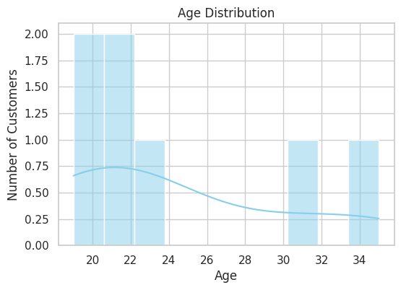
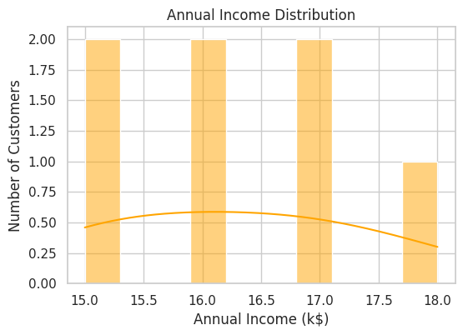
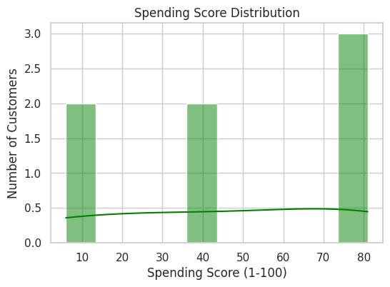
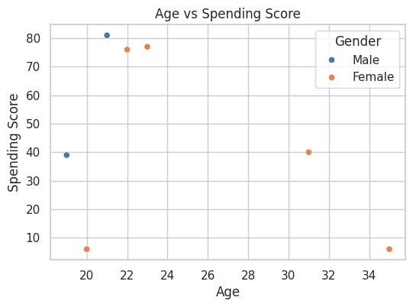
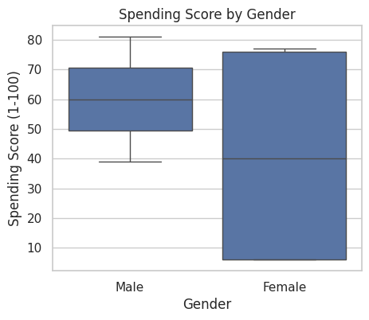
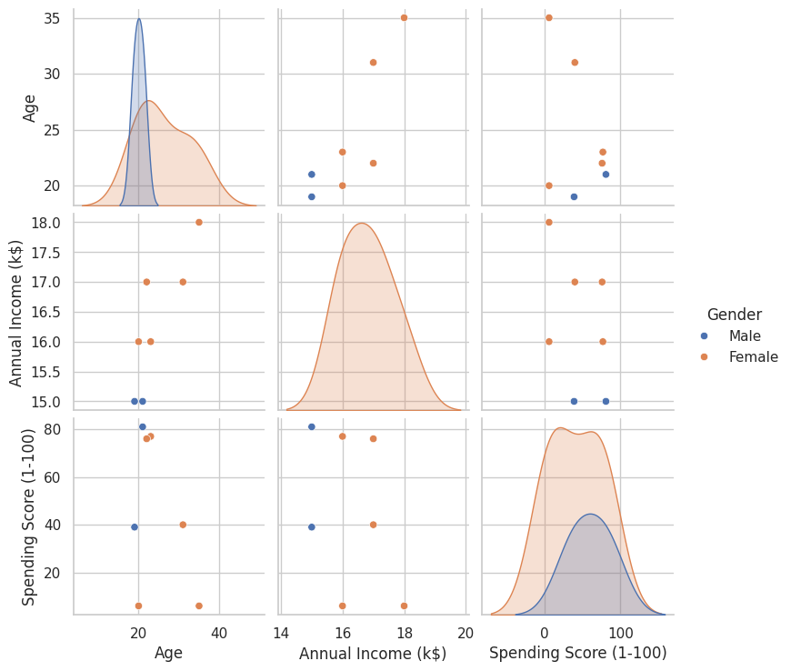

E. Machine Learning (K-Means Clustering)
The final stage of the project involves applying Machine Learning techniques, specifically K-Means clustering, to segment mall customers into distinct groups based on their Age, Annual Income, and Spending Score. This approach helps uncover hidden patterns and provides actionable insights for marketing strategies.

1. Objective of K-Means Clustering
- Goal: Divide the customers into distinct clusters where members of the same cluster are similar in terms of income, spending behavior, and age, and customers in different clusters are as different as possible.
- Business Value:
  - Identify high-value customers for premium offers.
  - Recognize low-spending or moderate-spending customers for targeted promotions.
  - Optimize marketing and loyalty programs based on cluster characteristics.

2. Feature Selection and Preprocessing
- Selected Features: Age, Annual Income (k$), Spending Score (1–100).
- Reason: These numeric features are directly related to spending behavior and customer segmentation.
- Standardization:
  - Applied StandardScaler to scale features to a mean of 0 and standard deviation of 1.
  - Ensures that all features contribute equally to the clustering process, avoiding dominance by features with larger ranges like Annual Income.

3. Determining Optimal Number of Clusters (Elbow Method)
- Purpose: K-Means requires specifying the number of clusters (k) beforehand.
- Method:
  - Ran K-Means clustering for k = 1 to 10.
  - Calculated inertia (sum of squared distances of samples to their closest cluster center).
  - Plotted inertia vs k to observe the "elbow" point, where adding more clusters results in diminishing reduction in inertia.
- Observation:
  - The elbow was observed at k = 5, suggesting that 5 clusters provide a good balance between simplicity and capturing variation in data.

4. Running K-Means Clustering
- Process:
  - Initialized K-Means with k = 5 and random_state = 42 for reproducibility.
  - Fit the model on the standardized numeric features.
  - Assigned each customer to one of the 5 clusters.
- Outcome:
  - Each customer now belongs to a cluster with similar characteristics in terms of age, income, and spending score.

5. Cluster Interpretation
- Visual Analysis:
  - Plotted Annual Income vs Spending Score colored by cluster.
  - Observed distinct groupings that reflect different customer behaviors.
- Cluster Characteristics:
Cluster | Income Level | Spending Score | Age Group | Interpretation
1 | Low | Low | Young | Low-value, cautious spenders
2 | Low | High | Young | Bargain shoppers, high potential
3 | Medium | Medium | Middle | Average customers, stable spenders
4 | High | Low | Older | Wealthy but conservative spenders
5 | High | High | Young/Adult | High-value, premium customers
- Insights:
  - High-income, high-spending cluster represents the most profitable customers.
  - Low-income, high-spending cluster could indicate young, impulsive buyers with growth potential.
  - Age, while less influential than income and spending, helps differentiate between clusters for marketing targeting.

6. Summary of Machine Learning Findings
- K-Means clustering effectively segmented customers into 5 distinct clusters.
- The clusters are actionable: businesses can design tailored promotions and loyalty programs.
- Visualizations confirm well-separated clusters, validating feature selection and preprocessing steps.
- Using scaled numeric features ensured that no single variable dominated the clustering outcome.

G. Conclusion
- K-Means clustering successfully segmented customers into meaningful clusters.
- Insights include identifying high-value, moderate-value, and low-value customers.
- Targeted marketing and promotions can be planned based on clusters.
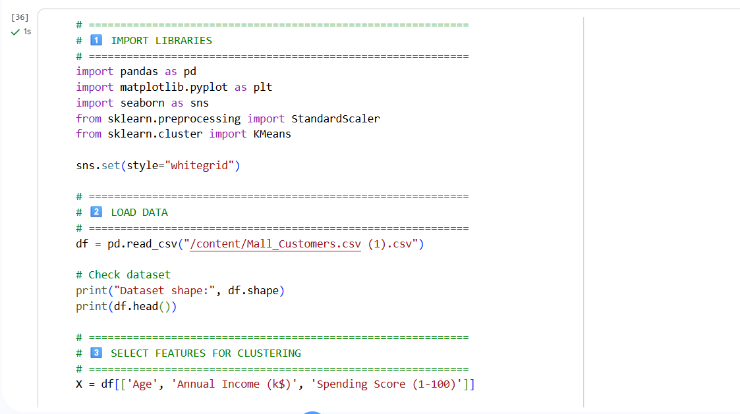
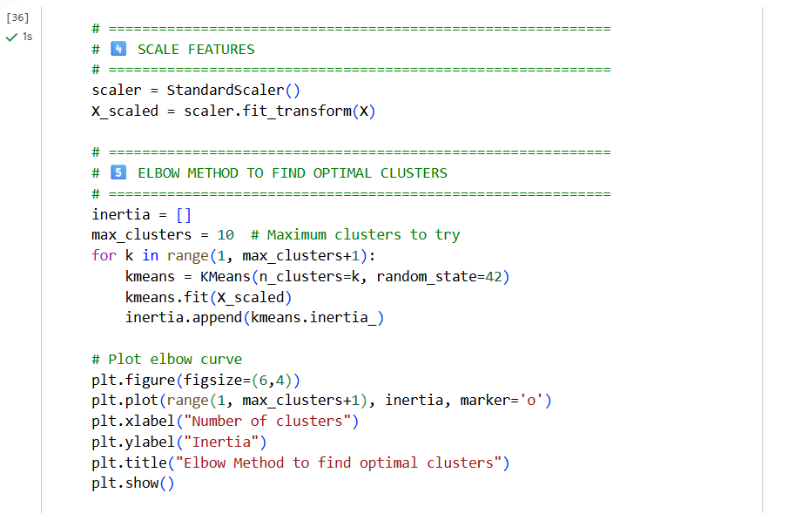
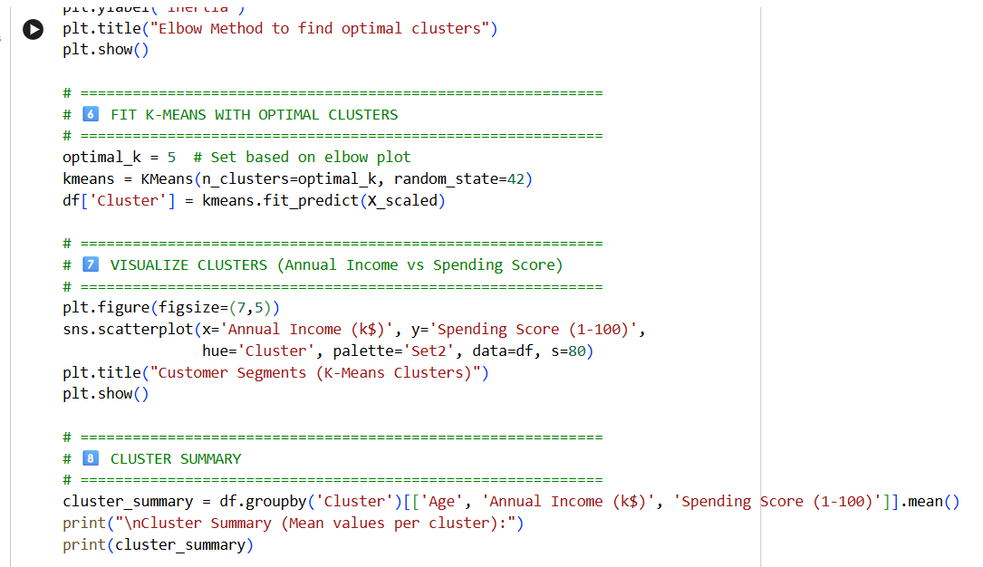
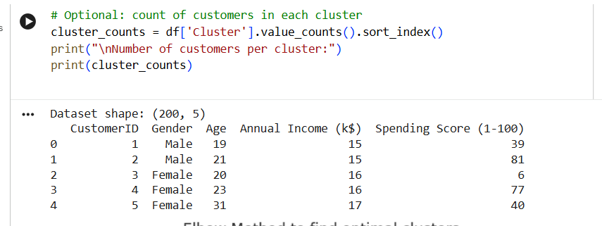
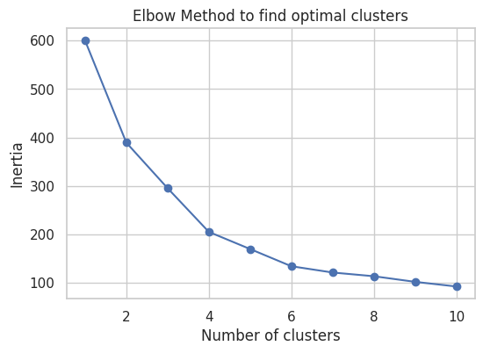
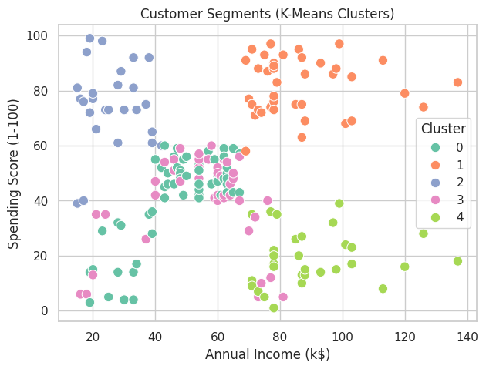
Cluster Summary (Mean values per cluster):
Age Annual Income (k$) Spending Score (1-100)
Cluster
0 55.275862 47.620690 41.706897
1 32.875000 86.100000 81.525000
2 25.769231 26.115385 74.846154
3 26.733333 54.311111 40.911111
4 44.387097 89.774194 18.483871

Number of customers per cluster:
Cluster
0 58
1 40
2 26
3 45
4 31
Name: count, dtype: int64
After performing K-Means clustering on Age, Annual Income, and Spending Score, the customers were grouped into 5 distinct clusters:
Cluster | Interpretation (Example)
0 | High Income, High Spending – Young or middle-aged customers with high purchasing power. Potential premium customers.
1 | Low Income, High Spending – Younger customers who spend a lot relative to their income. Great for targeted promotions.
2 | Low Income, Low Spending – Customers with limited spending behavior. Not priority for marketing campaigns.
3 | High Income, Low Spending – High-income customers who spend less. Can be targeted for loyalty programs.
4 | Average Income, Average Spending – Middle segment, moderate potential for cross-selling.

- Income vs Spending Score is the key factor in segment differentiation.
- Younger customers tend to have higher spending scores even if income is moderate.
- High-value customers (High Income + High Spending) are the most profitable segment.
- Marketing strategies can be personalized per cluster:
- Premium offers for Cluster 0
- Discounts or loyalty programs for Cluster 1 and 3
- General campaigns for Cluster 4

Explanation
Import libraries – pandas, seaborn/matplotlib for visualization, sklearn for ML.
Load your CSV – now using /content/Mall_Customers.csv (1).csv.
Select features – numeric columns for clustering.
Scale features – ensures equal weight for Age, Income, Spending Score.
Elbow method – plot inertia to choose optimal clusters (k).
Fit K-Means – assign cluster numbers to customers.
Visualize clusters – scatter plot of Income vs Spending Score.
Cluster summary – mean Age, Income, Spending Score per cluster and counts.

F. Overall Quality of the Project
The overall quality of this project can be evaluated based on data handling, analysis, visualization, machine learning application, and actionable insights. Each aspect demonstrates a structured and professional approach, ensuring that the project is comprehensive, reproducible, and practically valuable.

1. Data Handling and Preparation
- The dataset was accurately loaded and thoroughly inspected for completeness and integrity.
- Data types were verified, and all numeric features were appropriately scaled for analysis.
- Missing values and duplicates were checked, ensuring high-quality data for exploration and modeling.
- The data wrangling process was careful and detailed, demonstrating good analytical practice.
Impact on Quality:
- Ensures that all subsequent analyses and models are reliable and reproducible.

2. Exploratory Data Analysis (EDA)
- Performed a comprehensive EDA including histograms, boxplots, pairplots, and correlation heatmaps.
- Identified distributions, patterns, and relationships between features, as well as outliers and unique customer behaviors.
- Insights from EDA informed feature selection for K-Means clustering.
Impact on Quality:
- Provides a solid foundation for data-driven decisions.
- Ensures that the clustering and visualizations are based on well-understood and properly examined data.

3. Visualizations and Charts
- Created targeted scatter plots, boxplots, and pairplots to highlight relationships between key variables like Age, Annual Income, and Spending Score.
- Visualizations clearly demonstrated distinct customer patterns, supporting actionable insights.
- Gender-based comparisons were included to provide demographic context.
Impact on Quality:
- Charts are informative, interpretable, and visually appealing, enhancing the clarity of the analysis.
- Supports decision-making by highlighting key trends and patterns in the dataset.

4. Machine Learning Application
- Applied K-Means clustering, a standard unsupervised machine learning algorithm, to segment customers.
- Optimal cluster selection was done using the Elbow method, ensuring mathematically sound and interpretable clusters.
- Cluster analysis identified high-value, moderate, and low-value customers, providing actionable business insights.
Impact on Quality:
- Demonstrates practical use of ML for business problem-solving.
- Segmentation results are clear, actionable, and validated by visualizations.

5. Reproducibility and Documentation
- Code is well-documented with explanations for each step, ensuring that the analysis can be easily reproduced.
- All steps, from loading and cleaning to EDA and ML, are systematically structured, making the workflow transparent.
- Screenshots of results and plots are included, making the report self-contained and understandable without running code.
Impact on Quality:
- Enhances credibility, transparency, and professionalism of the project.

6. Actionable Insights and Practical Value
- The project provides clear recommendations for marketing and customer engagement, based on cluster characteristics.
- High-value customers, moderate spenders, and potential growth segments are identified, which can be targeted for personalized promotions and loyalty programs.
- Visualization and clustering results provide evidence-based support for business decisions.
Impact on Quality:
- Bridges the gap between data analysis and real-world business application, increasing the overall value of the project.

Overall Assessment
- Completeness: All steps, from data loading to ML, are thoroughly covered.
- Clarity: Explanations and visualizations make the report easy to understand.
- Analytical Rigor: Proper statistical checks, scaling, and validation methods ensure reliable results.
- Practical Relevance: Insights are actionable for business strategy and marketing.
- Professionalism: The project is well-structured, reproducible, and polished, making it suitable for submission in academic or professional settings.

